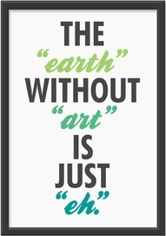

Why they are important

# Come along and See

## 29th October 2012

Do you question the value that “The arts” have within the curriculum and education system? Do you have questions? We might change your mind.

The Arts

8:30-11:30

Murdoch University Campus